Secretariat Report
IEU Federal Council Meeting
30 August 2023


Table of contents

Page No.
Introduction: ………………………..…………………………………………… 2

Professional engagement:
a year of reviews, inquiries, taskforces and roundtables ………… 3

Early Childhood Education takes centre stage……………………..5

Equity and diversity matters……………………………………………….6

IR reforms and new workplace rights……..................................7

IEU member activism ……………………………………………………….…8

International solidarity and action……………………………………...9

IEU governance and leadership …………………………………………10

Farewell to some IEU legends – thank you Christine, Deb & Glen


Thank you, Christine Cooper!

The IEU extends its thanks and deep appreciation to Christine who concluded her long and distinguished career as a senior elected IEU officer and union leader this year.

Christine’s many years of dedicated service, first at the QNT Branch level and then as IEU Federal Assistant Secretary and Federal Secretary, were instrumental in building the strength, capacity and influence of our union.

The IEU shall forever be thankful for the commitment and passionate contribution provided by Christine over her three decades of service to our members and the union movement more broadly.

The IEU also acknowledged and farewelled two other long-serving and extraordinary members of our union this year with the retirement of Deb James from the VICTAS Branch and Glen Seidel from South Australia.




Our Federal Executive, state Branches and colleague unions took the opportunity to farewell Deb and Glen and thank them for their decades of service to our union.

Glen and Deb - you will both be deeply missed!

Professional Engagement:
a year of reviews, inquiries, taskforces and roundtables

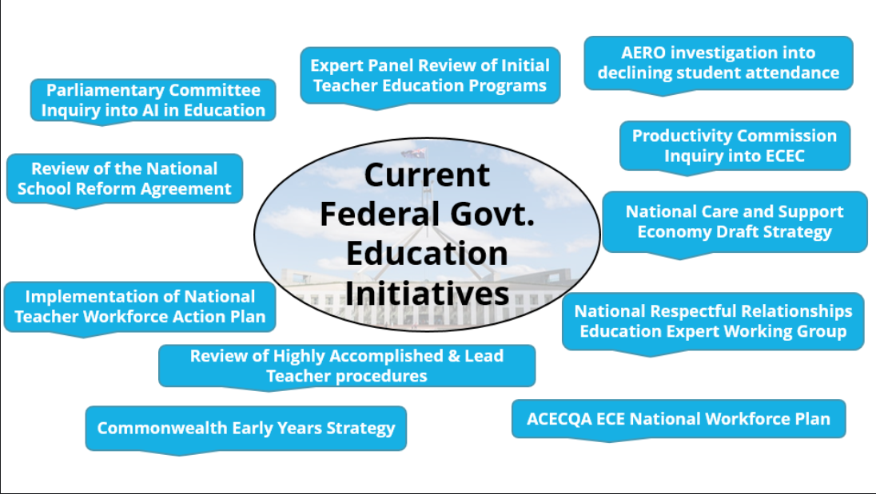

Engagement on federal government initiatives requires interaction with multiple agencies tasked with developing new policies and official advice. While some of these agencies, such as AITSL, ACARA, Australian Education Research Organisation (AERO) and the Australian Children's Education & Care Quality Authority (ACECQA) are well-known, the government and Department of Education are also out-sourcing some consultation to external groups, such as Behavioural Insights and Orima.

Since many of the federal government initiatives have been triggered as a response to the national teacher shortage and the advent of generative artificial intelligence, there is significant overlap in the advocacy positions taken by the IEU during our engagement, particularly on initiatives such as the National School Reforms Agreement (NSRA) review and the National Teacher Workforce Action Plan (NTWAP).

The IEU has maintained consistent messaging on core principles that are necessary to address the national teacher shortage and restore a stable and sustainable teaching profession, both through written submissions and meetings conducted face to face or online. These principles include the core assertions that uncompetitive salaries and unsustainable workloads are the root causes of the recruitment and retention issues in the education sector currently being experienced across the nation.

Links to all IEUA submissions can be found at https://www.ieu.org.au/policy-submission/

Amplifying the voice of the profession: core principles asserted by the IEU
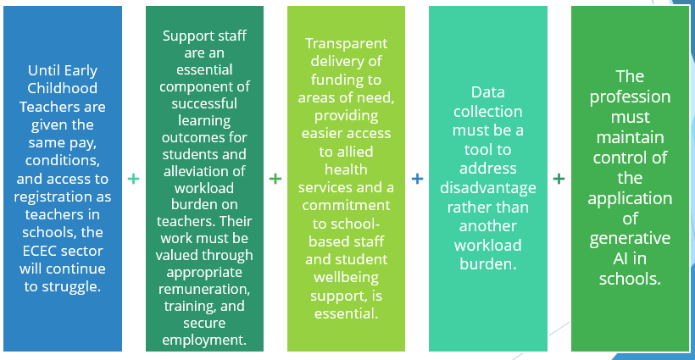
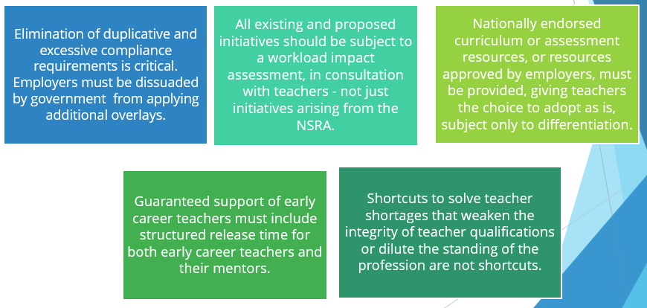

While there is a moral imperative to engage in educational issues and work to relieve the pressure on the profession, the parallel aim is to recruit members to the union through visible advocacy on workload issues, thereby increasing the influence of the IEU on all matters of concern to the education sector, including equity, organising and industrial matters.

Early Childhood Education takes centre stage

The importance of high-quality early childhood education emerged as a key public policy priority over the last 12 months. The IEU was instrumental in these developments and continues to lead the debate on ECE issues at the Branch and Federal level.

IEU joins the nation’s first supported bargaining application

The IEU joined the AEU and UWU in making
the first ever supported bargaining application
under new IR laws in June 2023.

The new multi-employer agreement will cover
65 early childhood education employers under
a new bargaining stream designed to lift wages
and conditions for workers previously excluded
from bargaining. This will be a crucial test case
of the new laws and the IEU is proud to be
leading the charge for ECE workers left behind
under previous IR laws.

ECE members heard loud and clear in government policy development

The IEU and our members have been directly engaged in the development of new education policies and workforce strategies critical to the ECE sector, including:

- The Productivity Commission Inquiry into ECEC
- The Commonwealth Early Years Strategy
- ACEQA’s ECE National Workforce Plan
- The ORIMA ECEC Workforce Project commissioned by the federal government

Members from the QNT and NSW/ACT Branch shared their insights and professional advice on the priority professional and workplace issues in the sector.


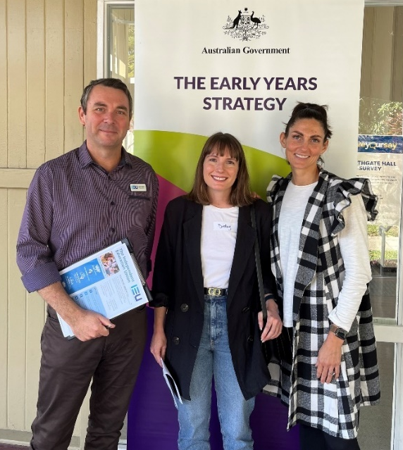

Equity and Diversity Matters

Unions for Yes! The IEU proudly embraces a First Nations Voice

Consistent with our union’s pledge to support the Uluru Statement from the Heart when first developed in 2017, the IEU has continued our strong commitment to Truth, Treaty and Voice,.

We stand in support of greater recognition and respect for our Aboriginal and Torres Strait Islander people, within their workplaces and within the broader community.



Unions believe in greater consultation, representation and inclusion. A First Nations Voice aligns with our core values. And this is why we will be voting YES!

IR reforms target gender pay gap and build greater workplace equity

Federal workplace reforms, secured by the power of union campaigns, have provided some optimism that real change can be achieved to reduce the gender pay gap and deliver greater equity across all workplaces. Recent legislative changes include:

- Outlawing of pay secrecy clauses
- Gender equality embedded in the objects of the FWA
- FWA prohibitions on sexual harassment
- A positive duty on employers to prevent harassment and discrimination
- Access to flexible work arrangements

As always, it will be union action that uses these reforms to force meaningful change.

A step closer to ending discrimination in our sector

Australia doesn’t condone blatant discrimination - except in thousands of our schools.

The federal government’s review of the special discrimination exemptions afforded to faith-based schools is long overdue.

All IEU members deserve workplaces free from discrimination, and we will continue to campaign until these important reforms are delivered.
IR reforms and new workplace rights

Unions were instrumental in securing recent IR reforms, and the IEU and our members were at the forefront of the political campaign to support the changes through parliament.

The new laws, the first of three planned tranches of changes, arose from lengthy campaigns to restore fairness to workplace laws. Key features for IEU members include:

Access to multi-employer bargaining: Tens of thousands of IEU members have been forced to bargain under a system that locked them out of multi-employer bargaining and denied basic bargaining rights. New multi-employer bargaining options now in place provide an opportunity for members to bargain on a level playing field where basic rights are restored.

The stories and experience of IEU members
were central to these bargaining reforms,
setting out to members of parliament the
clear case for change.

And now that the reforms are in place, our
members are front of the queue to benefit
from these new bargaining options. The IEU
is involved in the first supported bargaining
application (ECE workers in NSW and QLD),
as well as the first single-interest application (support staff in WA Catholic schools).

Fixed-term contracts: While final details are still to be drafted for implementation in December 2023, new laws to limit the use of fixed-term contracts have the potential to deliver more secure jobs for members across the country. For too long, countless school employees have been stuck on rolling short-term contracts. Our action under the proposed laws can help restore permanent work at the centre of employment practices.

Flexible work arrangements: Our members now have a substantive right to flexible work arrangements. We know that many employers in our sector routinely reject such requests without giving them due consideration. We can now fight for members desperately in need of job-share, part-time work or transition to retirement arrangements.
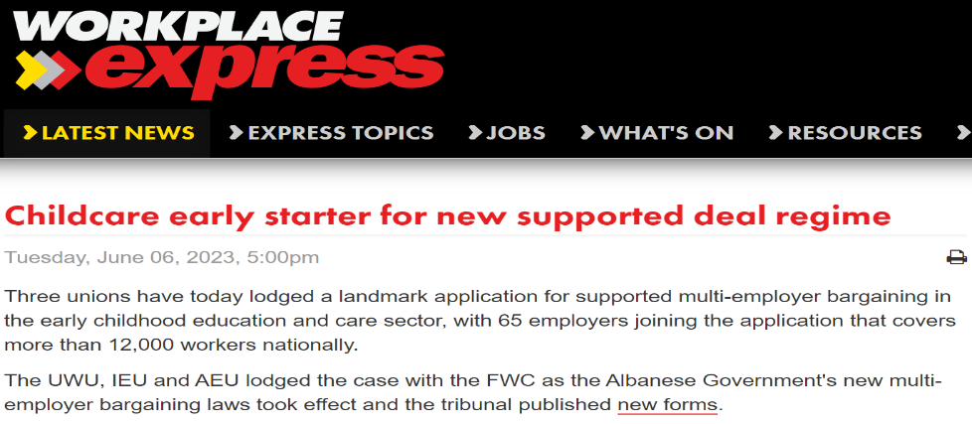

Another year of inspiring IEU member activism

The last 12 months has once again seen IEU Branches engaged in protracted bargaining campaigns and disputes across the Catholic and independent sectors.

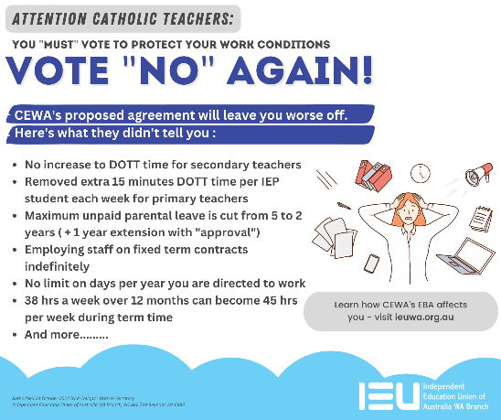
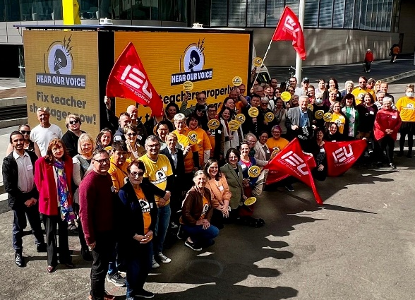

While specific member claims differ between Branches and employers, issues of unsustainable workloads and fair pay increases are common across all negotiations.

Improved pay outcomes and measures to tackle workload concerns are critical to address current teacher shortages. As usual, it will be IEU member campaigns that will make the positive change needed in our schools and in our classrooms.



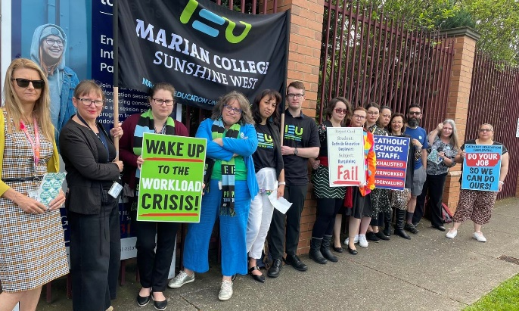
International solidarity and action

Council of Pacific Education (COPE): It’s been a period of change as we farewelled our former COPE Secretary General Govind Singh, and welcomed a new Secretary General Neselinda Meta. COPE continues to play a crucial role supporting the development of education unions across the Pacific. Climate change and the impact of Just Transition policies within the education system and school curriculum remain urgent concerns for all unions, but especially those in the Pacific. The IEU remains committed to support our Pacific neighbours to ensure worker and climate justice across the region.

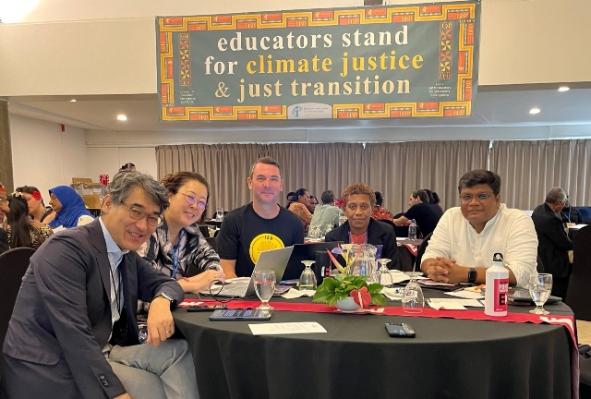

Ukraine: The IEU provided financial support to help rebuild Ukrainian schools and kindergartens destroyed by the Russian military. The plight of Ukrainian teachers and students trying deliver an education system in an active war zone remains an incredible and heart-breaking challenge. International union support by groups such as Education International is vital during the occupation by Russian forces, and will remain so to help rebuild after a Russian withdrawal.


NASUWT: An IEU delegation participated in the
International Roundtable at the annual NASUWT
Conference in the UK in April this year.

The similarities in experiences, particularly as
they related to bargaining in the school sector
were striking and provided an opportunity
for the sharing of union strategy and tactics.

APHEDA: The IEU remains a proud supporter of Union Aid Abroad APHEDA and encourages all Branches and IEU members to join with APHEDA to help build union solidarity and workers’ rights around the world. Our union remains particularly active within our region through our work with the Timor Leste Farm Workers Union.

IEU Governance and leadership

Federal IEU elections

Elections for the IEU Federal Executive were conducted this year in accordance with our federal rules.

Thank you to our Executive members who will continue to provide expert union leadership and governance throughout the term of office:

Federal President: Carol Matthews
Federal Secretary: Brad Hayes
Assistant Federal Secretary: Anthony Odgers
Assistant Federal Secretary: Veronica Yewdall
Deputy President: Terry Burke
Vice President: Rebecca Collopy
Vice President: David Brear
Executive Member: Mark Northam
Executive Member: Tim Oosterbaan

Welcome Christine Regan, our new Research, Advocacy and Policy Officer

The federal office welcomed the appointment of Christine Regan to the position of Federal Research, Advocacy and Policy Officer in July this year.

Christine brings a wealth of experience and knowledge from previous research, policy and union organiser roles in the education sector and ACT government administration.

Welcome to the IEU Christine!

Federal office relocation

The federal office finalised the move to new premises in Deakin along with the NSW / ACT Branch at the beginning of the year.

The new federal office provides an
outstanding and high-quality federal
union facility, and the work of the
NSW/ACT Branch in designing and
developing the new office space is
to be commended.

